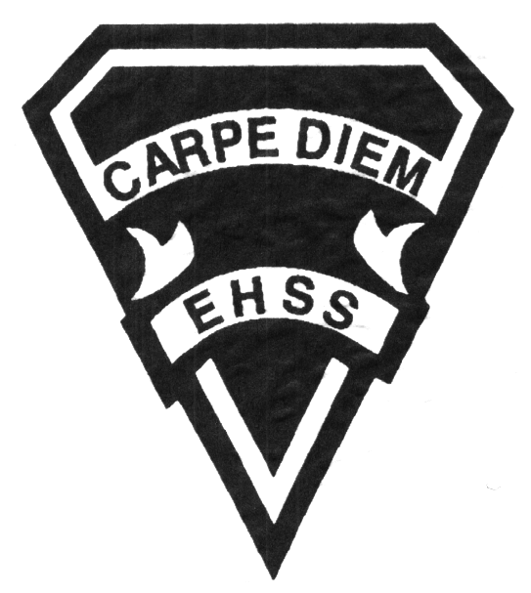

**2019/2020**

### Families in Canada

**Social Sciences Department**

## Earl Haig

SecondarySchool

# **HHS4U**

**Evaluation Profile & Outline**

Course Description/Rationale/Overview: This course applies current theories and research from the disciplines of anthropology, psychology, and sociology to the study of individual development, family behaviour, intimate and parent-child relationships, and the ways in which families interact within the diverse Canadian society.

**Class Requirements:** Students should have materials specified by the subject teacher at the beginning of the year.

The textbook for this course is Individuals and Families: Diverse Perspectives (ed. 2). Students will be issued this book at the beginning of the course. The replacement cost for this textbook $95.00.

**Assessment and Evaluation Strategies**

Students will also be expected to complete assessment activities of a formative nature in order to learn and to practice the specific expectations that will compose the summative evaluations. Examples of formative assessment may include homework checks, quizzes, peer assessment, presentations, reflection writing, role-play scenarios and observation.

Each unit or strand of the course will be evaluated using summative evaluations. Examples of summative evaluations are tests, case studies, interviews, reports, presentations, seminars, debates, research and other writing assignments.

**Late and/or Missed Evaluation**

##### Late Assignments*

For each assignment, the teacher will inform students of the due date. The teacher may decide to create an ultimate deadline. If an assignment is submitted after the deadline, the teacher may deduct marks up to and including the full value of the assignment.

**Missed Tests**

It is the student’s responsibility to make arrangements, ahead of time, for any tests/quizzes that are missed. If a student misses a test/quiz for an unforeseen reason such as illness, the student must bring a note signed by a parent or guardian**. Alternatively a medical certificate may be requested by the teacher.** The student must be prepared to write the test/quiz immediately upon return to school at a time determined by the teacher. Once the tests/quizzes have been evaluated and returned, students will not be able to make up a missed test - a mark of zero will be assigned.

**Subject-Specific/Department Information**

Teachers in the Social Sciences Department can be reached at (416) 395-3210, ext. 20075 or 20085. Parents wishing to meet with a teacher are requested to make an appointment with the teacher prior to coming to the school.

**Learning Skills\***

**Responsibility** – meets deadlines; takes responsibility for own behaviour

**Organization** – establishes priorities and manages time; uses information, technology and resources top complete tasks time management

**Independent Work** – follows instruction with minimal supervision; uses class time appropriately to complete tasks

**Collaboration** – accepts an equitable share of work in a group; builds healthy peer relationships; works with others to achieve group goals

**Initiative** – looks for opportunities for learning; demonstrates curiosity; approaches new tasks with a positive attitude

**Self-regulation** – sets own goals and monitors own progress; seeks assistance with needed; makes an effort with responding to challenges

###### Final Mark

The final mark for this course will be determined based upon an accumulation of marks from unit summative activities and from a final summative evaluation

**Year’s Work 70%**

This is a culmination of evaluations that have been completed throughout the year. It may include tests, presentations, research, or topic specific assignments.

**Final Summative Evaluation 30%**

This summative activities of the course will be comprised of the Seminar (15%) based on the Independent Study Project as well as a comprehensive final exam (15%) based on concepts and themes presented in the course.

**Achievement Categories and Weighting**

* **Knowledge / Understanding – 25%**

Knowledge of facts and terms; understanding of concepts, principles, guidelines and strategies; understanding of relationships among concepts.

* **Application – 25%**

Synthesizing knowledge and understanding into new and familiar contexts as well as making connections between various contexts.

* **Thinking Inquiry – 25%**

Formulating questions; planning, selecting strategies and resources; analyzing and interpreting information, and forming conclusions.

* **Communication – 25%**

Communication of information and ideas, communication for different audiences, use of various forms of communication.

*From: Ontario Ministry of Education. *Growing Success: Assessment, Evaluation, and Reporting in Ontario Schools*. Toronto: Ministry of Education, 2010, 11.



**2019/2020**

### Families in Canada

**Social Sciences Department**

## Earl Haig

SecondarySchool

# **HHS4U**

**Evaluation Profile & Outline**

**Course Outline:**

**Unit 1: All in the Family**

This unit establishes the framework for the study of individuals and families in Canada’s diverse society. The functions and diversity of Canadian families will be examined. Students will also learn about various theoretical perspectives from which individual and family behaviour can be viewed.

**Unit 2: Emerging Adulthood**

This unit investigates the transition of young Canadians into adulthood at the beginning of the 21st century. Research will be examined to determine when and how Canadians are leaving to live independently, finishing their education, finding jobs, and forming adult relationships. In addition to the psychological and developmental factors that influence young adults in their transition, relationships within the family and with others will also be explored.

**Unit 3: Intimate Relationships and Marriage in a Diverse Society**

In this unit, the conjugal relationships of Canadians, including marriage and alternative intimate relationships will be examined. The history marriage and intimate relationships will be traced as well as the diversity of conjugal relationships in Canada today. In addition, the psychology of attraction, courtship and mate selection and the factors that contribute to satisfying relationships for both men and women will be explored.

**Unit 4: Parent-Child Relationships in a Diverse Society**

This unit explores parent-child relationships will be explored through and analysis of related theories and research. The roles of children and parents in Canada will be traced and the trends in Canada today will be evaluated. Specific issues and trends such as divorce that has impacts on Canadian parent-child relationships will be discussed.

**Unit 5: Individuals and Families from Mid-to-Late Adulthood**

The lives of individuals in middle adulthood in discussed in this unit. To illustrate the role that adults of all ages play in Canadian society, the age transitions if adulthood, midlife, retirement, and old age will be outlined. The history and psychology of aging and the factors that contribute to satisfaction at each stage of life for both men and women will be examined.